**LIC MANAGEMENT SYSTEM**

**PROJECT REPORT**

**ON**

**“AUTOMATED LIC MANAGEMENT SYSTEM“**

**BY:**

**Nitin Gugale**

**Yogesh Dhome**

**Tushar Bhapkar**

**UNDER THE GUIDANCE OF**

PROF.RUPALI UMBARE

PROF. DEEPAK BADGUJAR.

**Project Approval Sheet**

The Project Entitled

**“ AUTOMATED LIC MANAGEMENT SYSTEM “**

**BY**

Name Exam No.

**Nitin Gugale**

**Yogesh Dhome**

**Tushar Bhapkar**

Is hereby approved in partial fulfillment

for the third year in Information Technology ( Term -1 ).

**PROF.RUPALI UMBARE PROF.S. P. PATIL**

GUIDEH.O.D.

**EXTERNAL EXAMINER DR.S.S.INAMDAR** PRINCIPAL

Department Of Information Technology

Sinhgad Institute of Technology, Lonavala.

2007–2008.

**CERTIFICATE**

**AUTOMATED LIC MANAGEMENT SYSTEM**

This is to certify that the above mentioned

project has been carried out by

Name Exam No.

**Nitin Gugale**

**Yogesh Dhome**

**Tushar Bhapkar**

Students of third year engineering (Term - 1)

2007-2008

Prof. Deepak Badgujar

Prof.Rupali Umbare

Guide

Department of Information Technology

Sinhgad Institute of Technology, Lonavala.

2007–2008.

**ACKNOWLEDGEMENT**

We would like to mention our sincere gratitude towards our principal **Dr.S.S.INAMDAR** and H.O.D. **Mr.S.P.PATIL**, IT- Department, for giving us opportunity to carry out our project.

We would like to express our heart full gratitude towards our guide, **Prof. RUPALI UMBARE**, for his invaluable advice for the successful completion of this dissertation.

We also like to extend our sincere thanks to other staff of the IT - Department for there invaluable help and support.

Finally we take this opportunity to mention our sincere thanks to one and all those who helped us directly or indirectly for the completion of our project.

**Nitin Gugale**

**Yogesh Dhome**

**Tushar Bhapkar**

**1. INTRODUCTION**

As we all know the LIC company involves a lot of database requirement, transactions and other complicated processes. So the work to be done in a LIC management system is lot.

Thus making software and computerizing all the work of the saves a lot of energy and manual work, thus saving cost by reducing the manpower required to do the huge amount of work.

Our software is quite small and simple as well as easy to handle as it requires very low maintenance. This software involves very less number of steps for entering, modifying or retrieving the data. Thus it is quite fast to work with.

One more specialty of this software is the User Accounts facility. This facility makes the software much secure as only users with accounts can perform the appropriate activity. Thus all the information of the customers will be safe, which is one of the very important concerns nowadays.

**2. PURPOSE**

The purpose of this project is to make such software which is small, efficient and simple to be used in LIC offices to manage information not only on customers but also on the Agents.

And this software serves this purpose successfully.

**5. Project Description**

This software is implemented in programming language Visual Basic and database stored in MS-Access. Connection between this projects and database are done in ODBC of control panels.

Active-x controls are used in the project that inbuilt applications are available for the project.

**SYSTEM:**

1. **Policy : -**

This form gives us the functionality of maintaining a proper record of all the clients those have take the policy of different plans. It helps to keep the record of new client and there policy plans.

1. **Premium: -**

This form gives facility to pay premium amount to client and also it helps to get claim amount to nominee.

1. **Premium Receipt:**

This form givespremium receipt to client that contains details about branch, premium status, client name, premium amount, due date, amount paid after due date.

1. **Search: -**

This form gives facility to user to search particular record by client id, client name, agent id, agent name, nominee id, nominee name etc.

1. **Details: -**

This form gives detail information about client, agent, policy, nominee, premium, claim, etc.

1. **Help : -**

This form gives facility to user to view the features of each policy. It also shows the benefits of each policy.

1. **MDI: -**

This form contains file strip of to select one of the form mentioned above.

**Advantages :**

**1. User accounts facility: -**

This software has user accounts facility which makes the information stored in this software safe and secure.

**2. Simple usability and user friendly: -**

This software is quite easy to use and user friendly as the steps to be performed for any operation is quite simple and straight-forward.

##### PROJECT CODES

##### Client Form :

##### private Sub cmbsex_Click()

##### txtffn.SetFocus

##### End Sub

##### Private Sub cmdhome_Click()

##### Unload Me

##### frmhome.Show

##### End Sub

##### Private Sub cmdproceed_Click()

##### If (txtfn.Text = "" Or txtmn.Text = "" Or txtsn.Text = "" Or cmbsex.Text = "" Or txtffn.Text = "" Or txtfmn.Text = "" Or txtfsn.Text = "" Or txtra.Text = "" Or txtpin.Text = "" Or txtnation.Text = "") Then

##### MsgBox "All * Marked Fields Are Compulsory!!!!!", vbExclamation

##### Else

##### Call max

##### con.Execute ("insert into client_info values(" + txtcid.Text + ",'" + txtfn.Text + "','" + txtmn.Text + "','" + txtsn.Text + "','" + cmbsex.Text + "','" + txtffn.Text + "','" + txtfmn.Text + "','" + txtfsn.Text + "','" + txtra.Text + "'," + txtmob.Text + "," + txtoff.Text + ",'" + txtemail.Text + "'," + txtpin.Text + ",'" + txtnation.Text + "'," + txtaid.Text + "," + txtpno.Text + ")")

##### Unload Me

##### frmpolicy.Show

##### End If

##### End Sub

##### Private Sub Form_Load()

##### Call conn

##### txtcid.Visible = False

##### txtaid.Visible = False

##### txtpno.Visible = False

##### End Sub

##### Public Function max()

##### Dim clientid As Integer

##### Dim rst As ADODB.Recordset

##### Set rst = New ADODB.Recordset

##### rst.Open "select max(client_id) from client_info", con, adOpenStatic, adLockOptimistic

##### If IsNull(rst.Fields(0)) Then

##### clientid = 1

##### txtcid.Text = clientid

##### Else

##### clientid = rst.Fields(0) + 1

##### txtcid.Text = clientid

##### End If

##### txtpno.Text = txtcid + 1000

##### txtaid.Text = txtcid + 3000

##### rst.Close

##### End Function

##### Private Sub txtemail_KeyPress(KeyAscii As Integer)

##### If (KeyAscii = 13) Then

##### txtpin.SetFocus

##### End If

##### End Sub

##### Private Sub txtffn_KeyPress(KeyAscii As Integer)

##### Dim nstr As String

##### Dim i As Integer

##### nstr = "0123456789`-=[]\;',./~!@#$%^&*()_+{}|:<>?"

##### i = InStr(nstr, Chr(KeyAscii))

##### If (i > 0) Then

##### KeyAscii = 0

##### MsgBox "Please Enter Character Only!!!!!", vbExclamation

##### Else

##### KeyAscii = Asc(UCase(Chr(KeyAscii)))

##### End If

##### If (KeyAscii = 13) Then

##### txtfmn.SetFocus

##### End If

##### End Sub

##### Private Sub txtfmn_KeyPress(KeyAscii As Integer)

##### Dim nstr As String

##### Dim i As Integer

##### nstr = "0123456789`-=[]\;',./~!@#$%^&*()_+{}|:<>?"

##### i = InStr(nstr, Chr(KeyAscii))

##### If (i > 0) Then

##### KeyAscii = 0

##### MsgBox "Please Enter Character Only!!!!!", vbExclamation

##### Else

##### KeyAscii = Asc(UCase(Chr(KeyAscii)))

##### End If

##### If (KeyAscii = 13) Then

##### txtfsn.SetFocus

##### End If

##### End Sub

##### Private Sub txtfn_KeyPress(KeyAscii As Integer)

##### Dim nstr As String

##### Dim i As Integer

##### nstr = "0123456789`-=[]\;',./~!@#$%^&*()_+{}|:<>?"

##### i = InStr(nstr, Chr(KeyAscii))

##### If (i > 0) Then

##### KeyAscii = 0

##### MsgBox "Please Enter Character Only!!!!!", vbExclamation

##### Else

##### KeyAscii = Asc(UCase(Chr(KeyAscii)))

##### End If

##### If (KeyAscii = 13) Then

##### txtmn.SetFocus

##### End If

##### End Sub

##### Private Sub txtfsn_KeyPress(KeyAscii As Integer)

##### Dim nstr As String

##### Dim i As Integer

##### nstr = "0123456789`-=[]\;',./~!@#$%^&*()_+{}|:<>?"

##### i = InStr(nstr, Chr(KeyAscii))

##### If (i > 0) Then

##### KeyAscii = 0

##### MsgBox "Please Enter Character Only!!!!!", vbExclamation

##### Else

##### KeyAscii = Asc(UCase(Chr(KeyAscii)))

##### End If

##### If (KeyAscii = 13) Then

##### txtra.SetFocus

##### End If

##### End Sub

##### Private Sub txtmn_KeyPress(KeyAscii As Integer)

##### Dim nstr As String

##### Dim i As Integer

##### nstr = "0123456789`-=[]\;',./~!@#$%^&*()_+{}|:<>?"

##### i = InStr(nstr, Chr(KeyAscii))

##### If (i > 0) Then

##### KeyAscii = 0

##### MsgBox "Please Enter Character Only!!!!!", vbExclamation

##### Else

##### KeyAscii = Asc(UCase(Chr(KeyAscii)))

##### End If

##### If (KeyAscii = 13) Then

##### txtsn.SetFocus

##### End If

##### End Sub

##### Private Sub txtmob_KeyPress(KeyAscii As Integer)

##### Dim nstr As String

##### Dim i As Integer

##### nstr = "0123456789"

##### i = InStr(nstr, Chr(KeyAscii))

##### If (i = 0 And KeyAscii <> 8 And KeyAscii <> 13) Then

##### KeyAscii = 0

##### MsgBox "Please Enter Integer Only!!!!!", vbExclamation

##### End If

##### If (KeyAscii = 13) Then

##### txtoff.SetFocus

##### End If

##### End Sub

##### Private Sub txtnation_KeyPress(KeyAscii As Integer)

##### Dim nstr As String

##### Dim i As Integer

##### nstr = "0123456789`-=[]\;',./~!@#$%^&*()_+{}|:<>?"

##### i = InStr(nstr, Chr(KeyAscii))

##### If (i > 0) Then

##### KeyAscii = 0

##### MsgBox "Please Enter Character Only!!!!!", vbExclamation

##### Else

##### KeyAscii = Asc(UCase(Chr(KeyAscii)))

##### End If

##### If (KeyAscii = 13) Then

##### cmdproceed.SetFocus

##### End If

##### End Sub

##### Private Sub txtoff_KeyPress(KeyAscii As Integer)

##### Dim nstr As String

##### Dim i As Integer

##### nstr = "0123456789"

##### i = InStr(nstr, Chr(KeyAscii))

##### If (i = 0 And KeyAscii <> 8 And KeyAscii <> 13) Then

##### KeyAscii = 0

##### MsgBox "Please Enter Integer Only!!!!!", vbExclamation

##### End If

##### If (KeyAscii = 13) Then

##### txtemail.SetFocus

##### End If

##### End Sub

##### Private Sub txtpin_KeyPress(KeyAscii As Integer)

##### Dim nstr As String

##### Dim i As Integer

##### nstr = "0123456789"

##### i = InStr(nstr, Chr(KeyAscii))

##### If (i = 0 And KeyAscii <> 8 And KeyAscii <> 13) Then

##### KeyAscii = 0

##### MsgBox "Please Enter Integer Only!!!!!", vbExclamation

##### End If

##### If (KeyAscii = 13) Then

##### txtnation.SetFocus

##### End If

##### End Sub

##### Private Sub txtra_KeyPress(KeyAscii As Integer)

##### Dim nstr As String

##### Dim i As Integer

##### nstr = "`=[]\;~!@#$%^*+{}|:<>?"

##### i = InStr(nstr, Chr(KeyAscii))

##### If (i > 0) Then

##### KeyAscii = 0

##### MsgBox "Special Characters Are Not Allowed!!!!!", vbExclamation

##### End If

##### If (KeyAscii = 13) Then

##### txtmob.SetFocus

##### End If

##### End Sub

##### Private Sub txtsn_KeyPress(KeyAscii As Integer)

##### Dim nstr As String

##### Dim i As Integer

##### nstr = "0123456789`-=[]\;',./~!@#$%^&*()_+{}|:<>?"

##### i = InStr(nstr, Chr(KeyAscii))

##### If (i > 0) Then

##### KeyAscii = 0

##### MsgBox "Please Enter Character Only!!!!!", vbExclamation

##### Else

##### KeyAscii = Asc(UCase(Chr(KeyAscii)))

##### End If

##### If (KeyAscii = 13) Then

##### cmbsex.SetFocus

##### End If

##### End Sub

##### Agent Form:

##### Private Sub cmbwa_Click()

##### txtamob.SetFocus

##### End Sub

##### Private Sub cmdback_Click()

##### Call max

##### If (txtcid.Text = "0") Then

##### Else

##### con.Execute ("delete from other_info where client_id = " + txtcid.Text + "")

##### con.Execute ("delete from premium_info where client_id = " + txtcid.Text + "")

##### End If

##### If (txtpid.Text = "0") Then

##### Else

##### con.Execute ("delete from policy_info where pol_no = " + txtpid.Text + "")

##### End If

##### Unload Me

##### frmclient.Show

##### End Sub

##### Private Sub cmdhome_Click()

##### If (cmdsave.Enabled = True) Then

##### If (txtcid.Text = "0") Then

##### Else

##### con.Execute ("delete from client_info where client_id = " + txtcid.Text + "")

##### con.Execute ("delete from other_info where client_id = " + txtcid.Text + "")

##### con.Execute ("delete from premium_info where client_id=" + txtcid.Text + "")

##### End If

##### If (txtpid.Text = "0") Then

##### Else

##### con.Execute ("delete from policy_info where pol_no = " + txtpid.Text + "")

##### End If

##### End If

##### Unload Me

##### frmhome.Show

##### End Sub

##### Private Sub cmdsave_Click()

##### If (txtnfn.Text = "" Or txtnmn.Text = "" Or txtnsn.Text = "" Or txtnadd.Text = "" Or txtnage.Text = "" Or txtrel.Text = "" Or txtnpin.Text = "" Or txtafn.Text = "" Or txtamn.Text = "" Or txtasn.Text = "" Or txtaadd.Text = "" Or txtaage.Text = "" Or cmbwa.Text = "" Or txtapin.Text = "") Then

##### MsgBox "All * Marked Fields Are Compulsory!!!!!", vbExclamation

##### Else

##### Call max1

##### con.Execute ("insert into nominee_info values(" + txtnid.Text + ",'" + txtnfn.Text + "','" + txtnmn.Text + "','" + txtnsn.Text + "','" + txtnadd.Text + "'," + txtnmob.Text + "," + txtnoff.Text + ",'" + txtnemail.Text + "'," + txtnpin.Text + "," + txtnage.Text + ",'" + txtrel.Text + "'," + txtcid.Text + ")")

##### con.Execute ("insert into agent_info values(" + txtaid.Text + ",'" + txtafn.Text + "','" + txtamn.Text + "','" + txtasn.Text + "','" + txtaadd.Text + "'," + txtamob.Text + "," + txtaoff.Text + ",'" + txtaemail.Text + "'," + txtapin.Text + "," + txtaage.Text + ",'" + cmbwa.Text + "')")

##### MsgBox "Record Saved Successfully.....", vbInformation

##### cmdsave.Enabled = False

##### cmdback.Enabled = False

##### End If

##### End Sub

##### Private Sub Form_Load()

##### Call conn

##### txtcid.Visible = False

##### txtaid.Visible = False

##### txtnid.Visible = False

##### End Sub

##### Public Function max()

##### Dim clientid As Integer

##### Dim rst As ADODB.Recordset

##### Set rst = New ADODB.Recordset

##### rst.Open "select max(client_id) from client_info", con, adOpenStatic, adLockOptimistic

##### If IsNull(rst.Fields(0)) Then

##### clientid = 0

##### txtcid.Text = clientid

##### Else

##### clientid = rst.Fields(0)

##### txtcid.Text = clientid

##### End If

##### rst.Close

##### Set rst = New ADODB.Recordset

##### rst.Open "select max(pol_no) from policy_info", con, adOpenStatic, adLockOptimistic

##### If IsNull(rst.Fields(0)) Then

##### clientid = 0

##### txtpid.Text = clientid

##### Else

##### clientid = rst.Fields(0)

##### txtpid.Text = clientid

##### End If

##### rst.Close

##### End Function

##### Public Function max1()

##### Dim id As Integer

##### Dim rst As ADODB.Recordset

##### Set rst = New ADODB.Recordset

##### rst.Open "select max(agent_id) from agent_info", con, adOpenStatic, adLockOptimistic

##### If IsNull(rst.Fields(0)) Then

##### id = 3001

##### txtaid.Text = id

##### Else

##### id = rst.Fields(0) + 1

##### txtaid.Text = id

##### End If

##### rst.Close

##### Set rst = New ADODB.Recordset

##### rst.Open "select max(nominee_id) from nominee_info", con, adOpenStatic, adLockOptimistic

##### If IsNull(rst.Fields(0)) Then

##### id = 2001

##### txtnid.Text = id

##### Else

##### id = rst.Fields(0) + 1

##### txtnid.Text = id

##### End If

##### rst.Close

##### Set rst = New ADODB.Recordset

##### rst.Open "select max(client_id) from client_info", con, adOpenStatic, adLockOptimistic

##### If IsNull(rst.Fields(0)) Then

##### id = 0

##### txtcid.Text = id

##### Else

##### id = rst.Fields(0)

##### txtcid.Text = id

##### End If

##### rst.Close

##### End Function

##### Private Sub txtaadd_KeyPress(KeyAscii As Integer)

##### Dim nstr As String

##### Dim i As Integer

##### nstr = "=[]\~!@#$%^*+{}|:<>?"

##### i = InStr(nstr, Chr(KeyAscii))

##### If (i > 0) Then

##### KeyAscii = 0

##### MsgBox "Special Characters Are Not Allowed!!!!!", vbExclamation

##### End If

##### If (KeyAscii = 13) Then

##### txtaage.SetFocus

##### End If

##### End Sub

##### Private Sub txtaage_KeyPress(KeyAscii As Integer)

##### Dim nstr As String

##### Dim i As Integer

##### nstr = "0123456789"

##### i = InStr(nstr, Chr(KeyAscii))

##### If (i = 0 And KeyAscii <> 8 And KeyAscii <> 13) Then

##### KeyAscii = 0

##### MsgBox "Please Enter Integer Only!!!!!", vbExclamation

##### End If

##### If (KeyAscii = 13) Then

##### cmbwa.SetFocus

##### End If

##### End Sub

##### Private Sub txtaemail_KeyPress(KeyAscii As Integer)

##### If (KeyAscii = 13) Then

##### txtapin.SetFocus

##### End If

##### End Sub

##### Private Sub txtafn_KeyPress(KeyAscii As Integer)

##### Dim nstr As String

##### Dim i As Integer

##### nstr = "0123456789`-=[]\;'/~!@#$%^&*()_+{}|:<>?"

##### i = InStr(nstr, Chr(KeyAscii))

##### If (i > 0) Then

##### KeyAscii = 0

##### MsgBox "Please Enter Character Only!!!!!", vbExclamation

##### Else

##### KeyAscii = Asc(UCase(Chr(KeyAscii)))

##### End If

##### If (KeyAscii = 13) Then

##### txtamn.SetFocus

##### End If

##### End Sub

##### Private Sub txtamn_KeyPress(KeyAscii As Integer)

##### Dim nstr As String

##### Dim i As Integer

##### nstr = "0123456789`-=[]\;'/~!@#$%^&*()_+{}|:<>?"

##### i = InStr(nstr, Chr(KeyAscii))

##### If (i > 0) Then

##### KeyAscii = 0

##### MsgBox "Please Enter Character Only!!!!!", vbExclamation

##### Else

##### KeyAscii = Asc(UCase(Chr(KeyAscii)))

##### End If

##### If (KeyAscii = 13) Then

##### txtasn.SetFocus

##### End If

##### End Sub

##### Private Sub txtamob_KeyPress(KeyAscii As Integer)

##### Dim nstr As String

##### Dim i As Integer

##### nstr = "0123456789"

##### i = InStr(nstr, Chr(KeyAscii))

##### If (i = 0 And KeyAscii <> 8 And KeyAscii <> 13) Then

##### KeyAscii = 0

##### MsgBox "Please Enter Integer Only!!!!!", vbExclamation

##### End If

##### If (KeyAscii = 13) Then

##### txtaoff.SetFocus

##### End If

##### End Sub

##### Private Sub txtaoff_KeyPress(KeyAscii As Integer)

##### Dim nstr As String

##### Dim i As Integer

##### nstr = "0123456789"

##### i = InStr(nstr, Chr(KeyAscii))

##### If (i = 0 And KeyAscii <> 8 And KeyAscii <> 13) Then

##### KeyAscii = 0

##### MsgBox "Please Enter Integer Only!!!!!", vbExclamation

##### End If

##### If (KeyAscii = 13) Then

##### txtaemail.SetFocus

##### End If

##### End Sub

##### Private Sub txtapin_KeyPress(KeyAscii As Integer)

##### Dim nstr As String

##### Dim i As Integer

##### nstr = "0123456789"

##### i = InStr(nstr, Chr(KeyAscii))

##### If (i = 0 And KeyAscii <> 8 And KeyAscii <> 13) Then

##### KeyAscii = 0

##### MsgBox "Please Enter Integer Only!!!!!", vbExclamation

##### End If

##### If (KeyAscii = 13) Then

##### cmdsave.SetFocus

##### End If

##### End Sub

##### Private Sub txtasn_KeyPress(KeyAscii As Integer)

##### Dim nstr As String

##### Dim i As Integer

##### nstr = "0123456789`-=[]\;'/~!@#$%^&*()_+{}|:<>?"

##### i = InStr(nstr, Chr(KeyAscii))

##### If (i > 0) Then

##### KeyAscii = 0

##### MsgBox "Please Enter Character Only!!!!!", vbExclamation

##### Else

##### KeyAscii = Asc(UCase(Chr(KeyAscii)))

##### End If

##### If (KeyAscii = 13) Then

##### txtaadd.SetFocus

##### End If

##### End Sub

##### Private Sub txtnadd_KeyPress(KeyAscii As Integer)

##### Dim nstr As String

##### Dim i As Integer

##### nstr = "=[]\~!@#$%^*+{}|:<>?"

##### i = InStr(nstr, Chr(KeyAscii))

##### If (i > 0) Then

##### KeyAscii = 0

##### MsgBox "Special Characters Are Not Allowed!!!!!", vbExclamation

##### End If

##### If (KeyAscii = 13) Then

##### txtnage.SetFocus

##### End If

##### End Sub

##### Private Sub txtnage_KeyPress(KeyAscii As Integer)

##### Dim nstr As String

##### Dim i As Integer

##### nstr = "0123456789"

##### i = InStr(nstr, Chr(KeyAscii))

##### If (i = 0 And KeyAscii <> 8 And KeyAscii <> 13) Then

##### KeyAscii = 0

##### MsgBox "Please Enter Integer Only!!!!!", vbExclamation

##### End If

##### If (KeyAscii = 13) Then

##### txtrel.SetFocus

##### End If

##### End Sub

##### Private Sub txtnemail_KeyPress(KeyAscii As Integer)

##### If (KeyAscii = 13) Then

##### txtnpin.SetFocus

##### End If

##### End Sub

##### Private Sub txtnfn_KeyPress(KeyAscii As Integer)

##### Dim nstr As String

##### Dim i As Integer

##### nstr = "0123456789`-=[]\;'/~!@#$%^&*()_+{}|:<>?"

##### i = InStr(nstr, Chr(KeyAscii))

##### If (i > 0) Then

##### KeyAscii = 0

##### MsgBox "Please Enter Character Only!!!!!", vbExclamation

##### Else

##### KeyAscii = Asc(UCase(Chr(KeyAscii)))

##### End If

##### If (KeyAscii = 13) Then

##### txtnmn.SetFocus

##### End If

##### End Sub

##### Private Sub txtnmn_KeyPress(KeyAscii As Integer)

##### Dim nstr As String

##### Dim i As Integer

##### nstr = "0123456789`-=[]\;'/~!@#$%^&*()_+{}|:<>?"

##### i = InStr(nstr, Chr(KeyAscii))

##### If (i > 0) Then

##### KeyAscii = 0

##### MsgBox "Please Enter Character Only!!!!!", vbExclamation

##### Else

##### KeyAscii = Asc(UCase(Chr(KeyAscii)))

##### End If

##### If (KeyAscii = 13) Then

##### txtnsn.SetFocus

##### End If

##### End Sub

##### Private Sub txtnmob_KeyPress(KeyAscii As Integer)

##### Dim nstr As String

##### Dim i As Integer

##### nstr = "0123456789"

##### i = InStr(nstr, Chr(KeyAscii))

##### If (i = 0 And KeyAscii <> 8 And KeyAscii <> 13) Then

##### KeyAscii = 0

##### MsgBox "Please Enter Integer Only!!!!!", vbExclamation

##### End If

##### If (KeyAscii = 13) Then

##### txtnoff.SetFocus

##### End If

##### End Sub

##### Private Sub txtnoff_KeyPress(KeyAscii As Integer)

##### Dim nstr As String

##### Dim i As Integer

##### nstr = "0123456789"

##### i = InStr(nstr, Chr(KeyAscii))

##### If (i = 0 And KeyAscii <> 8 And KeyAscii <> 13) Then

##### KeyAscii = 0

##### MsgBox "Please Enter Integer Only!!!!!", vbExclamation

##### End If

##### If (KeyAscii = 13) Then

##### txtnemail.SetFocus

##### End If

##### End Sub

##### Private Sub txtnpin_KeyPress(KeyAscii As Integer)

##### Dim nstr As String

##### Dim i As Integer

##### nstr = "0123456789"

##### i = InStr(nstr, Chr(KeyAscii))

##### If (i = 0 And KeyAscii <> 8 And KeyAscii <> 13) Then

##### KeyAscii = 0

##### MsgBox "Please Enter Integer Only!!!!!", vbExclamation

##### End If

##### If (KeyAscii = 13) Then

##### txtafn.SetFocus

##### End If

##### End Sub

##### Private Sub txtnsn_KeyPress(KeyAscii As Integer)

##### Dim nstr As String

##### Dim i As Integer

##### nstr = "0123456789`-=[]\;'/~!@#$%^&*()_+{}|:<>?"

##### i = InStr(nstr, Chr(KeyAscii))

##### If (i > 0) Then

##### KeyAscii = 0

##### MsgBox "Please Enter Character Only!!!!!", vbExclamation

##### Else

##### KeyAscii = Asc(UCase(Chr(KeyAscii)))

##### End If

##### If (KeyAscii = 13) Then

##### txtnadd.SetFocus

##### End If

##### End Sub

##### Private Sub txtrel_KeyPress(KeyAscii As Integer)

##### Dim nstr As String

##### Dim i As Integer

##### nstr = "0123456789`-=[]\;'/~!@#$%^&*()_+{}|:<>?"

##### i = InStr(nstr, Chr(KeyAscii))

##### If (i > 0) Then

##### KeyAscii = 0

##### MsgBox "Please Enter Character Only!!!!!", vbExclamation

##### End If

##### If (KeyAscii = 13) Then

##### txtnmob.SetFocus

##### End If

##### End Sub

##### Policy Details:

##### Private Sub cmbmode_Click()

##### If (cmbpid.Text = "160") Then

##### If (cmbmode.Text = "Half-Yearly") Then

##### MsgBox "Half-Yearly Mode Is Not Present!!!!!", vbExclamation

##### End If

##### End If

##### End Sub

##### Private Sub cmbpid_Click()

##### If (cmbpid.Text = "149") Then

##### cmbamt.Clear

##### cmbdur.Clear

##### cmbcage.Clear

##### txtpname.Text = "Jeevan Anand"

##### cmbamt.AddItem "100000"

##### cmbamt.AddItem "500000"

##### cmbamt.AddItem "1000000"

##### cmbdur.AddItem "10"

##### cmbdur.AddItem "15"

##### cmbdur.AddItem "20"

##### cmbdur.AddItem "25"

##### cmbcage.AddItem "19"

##### cmbcage.AddItem "20"

##### cmbcage.AddItem "21"

##### cmbcage.AddItem "22"

##### cmbcage.AddItem "23"

##### ElseIf (cmbpid.Text = "102") Then

##### cmbamt.Clear

##### cmbdur.Clear

##### cmbcage.Clear

##### txtpname.Text = "Jeevan Kishor"

##### cmbamt.AddItem "50000"

##### cmbamt.AddItem "100000"

##### cmbamt.AddItem "200000"

##### cmbdur.AddItem "20"

##### cmbdur.AddItem "25"

##### cmbdur.AddItem "30"

##### cmbcage.AddItem "0"

##### cmbcage.AddItem "1"

##### cmbcage.AddItem "2"

##### cmbcage.AddItem "3"

##### cmbcage.AddItem "4"

##### cmbcage.AddItem "5"

##### cmbcage.AddItem "6"

##### cmbcage.AddItem "7"

##### ElseIf (cmbpid.Text = "89") Then

##### cmbamt.Clear

##### cmbdur.Clear

##### cmbcage.Clear

##### txtpname.Text = "Jeevan Saathi"

##### cmbamt.AddItem "50000"

##### cmbamt.AddItem "100000"

##### cmbamt.AddItem "200000"

##### cmbdur.AddItem "20"

##### cmbdur.AddItem "25"

##### cmbdur.AddItem "30"

##### cmbcage.AddItem "24"

##### cmbcage.AddItem "25"

##### cmbcage.AddItem "26"

##### cmbcage.AddItem "27"

##### ElseIf (cmbpid.Text = "91") Then

##### cmbamt.Clear

##### cmbdur.Clear

##### cmbcage.Clear

##### txtpname.Text = "Jana Raksha"

##### cmbamt.AddItem "30000"

##### cmbamt.AddItem "50000"

##### cmbamt.AddItem "100000"

##### cmbdur.AddItem "15"

##### cmbdur.AddItem "20"

##### cmbdur.AddItem "25"

##### cmbcage.AddItem "20"

##### cmbcage.AddItem "21"

##### cmbcage.AddItem "22"

##### cmbcage.AddItem "23"

##### ElseIf (cmbpid.Text = "160") Then

##### cmbamt.Clear

##### cmbdur.Clear

##### cmbcage.Clear

##### txtpname.Text = "Jeevan Bharati"

##### cmbamt.AddItem "50000"

##### cmbamt.AddItem "100000"

##### cmbamt.AddItem "200000"

##### cmbamt.AddItem "500000"

##### cmbdur.AddItem "15"

##### cmbdur.AddItem "20"

##### cmbcage.AddItem "25"

##### cmbcage.AddItem "26"

##### cmbcage.AddItem "27"

##### cmbcage.AddItem "28"

##### cmbcage.AddItem "29"

##### cmbcage.AddItem "30"

##### cmbcage.AddItem "31"

##### cmbcage.AddItem "32"

##### cmbcage.AddItem "33"

##### cmbcage.AddItem "34"

##### cmbcage.AddItem "35"

##### ElseIf (cmbpid.Text = "164") Then

##### cmbamt.Clear

##### cmbdur.Clear

##### cmbcage.Clear

##### txtpname.Text = "Anmol Jeevan"

##### cmbamt.AddItem "1000000"

##### cmbdur.AddItem "10"

##### cmbdur.AddItem "15"

##### cmbdur.AddItem "20"

##### cmbdur.AddItem "25"

##### cmbcage.AddItem "20"

##### cmbcage.AddItem "21"

##### cmbcage.AddItem "22"

##### cmbcage.AddItem "23"

##### End If

##### End Sub

##### Private Sub cmdback_Click()

##### Call max

##### If (txtcid.Text = "0") Then

##### Else

##### con.Execute ("delete from client_info where client_id = " + txtcid.Text + "")

##### End If

##### Unload Me

##### frmclient.Show

##### End Sub

##### Private Sub cmdhome_Click()

##### Call max

##### If (txtcid.Text = "0") Then

##### Else

##### con.Execute ("delete from client_info where client_id = " + txtcid.Text + "")

##### End If

##### Unload Me

##### frmhome.Show

##### End Sub

##### Private Sub cmdproceed_Click()

##### If (cmbpid.Text = "" Or txtpname.Text = "" Or cmbdur.Text = "" Or cmbamt.Text = "" Or cmbmode.Text = "" Or dtpckpd.Value = "" Or cmbcage.Text = "" Or txtpo.Text = "" Or txtenod.Text = "" Or txtai.Text = "" Or txtsoi.Text = "") Then

##### MsgBox "All * Marked Fields Are Compulsory!!!!!", vbExclamation

##### Else

##### Dim fine As Integer

##### Dim rst As ADODB.Recordset

##### Call max1

##### con.Execute ("insert into policy_info values(" + txtpno.Text + "," + cmbpid.Text + ",'" + txtpname.Text + "'," + cmbamt.Text + "," + cmbdur.Text + ",'" + cmbmode.Text + "','" + CStr(dtpckpd.Value) + "'," + cmbcage.Text + ")")

##### 'con.Execute ("insert into other_info values(" + txtcid.Text + ",'" + txtpo.Text + "','" + txtenod.Text + "','" + txtnope.Text + "'," + txtloswh.Text + ",'" + txteq.Text + "'," + txtai.Text + ",'" + txtsoi.Text + "'," + txtpn.Text + ")")

##### Set rst = New ADODB.Recordset

##### rst.Open "select agent_id from client_info where client_id=" + txtcid.Text + "", con, adOpenStatic, adLockOptimistic

##### txtaid.Text = rst.Fields(0)

##### rst.Close

##### If (cmbpid.Text = "149") Then

##### If (cmbamt.Text = "100000") Then

##### If (cmbmode.Text = "Yearly") Then

##### rst.Open "select onelac_yr from jeevan_anand where pol_id=" + cmbpid.Text + " and client_age=" + cmbcage.Text + " and pol_duration ='" + cmbdur.Text + "'", con, adOpenStatic, adLockOptimistic

##### Else

##### rst.Open "select onelac_hr from jeevan_anand where pol_id=" + cmbpid.Text + " and client_age=" + cmbcage.Text + " and pol_duration ='" + cmbdur.Text + "'", con, adOpenStatic, adLockOptimistic

##### End If

##### ElseIf (cmbamt.Text = "500000") Then

##### If (cmbmode.Text = "Yearly") Then

##### rst.Open "select fivelac_yr from jeevan_anand where pol_id=" + cmbpid.Text + " and client_age=" + cmbcage.Text + " and pol_duration ='" + cmbdur.Text + "'", con, adOpenStatic, adLockOptimistic

##### Else

##### rst.Open "select fivelac_hr from jeevan_anand where pol_id=" + cmbpid.Text + " and client_age=" + cmbcage.Text + " and pol_duration ='" + cmbdur.Text + "'", con, adOpenStatic, adLockOptimistic

##### End If

##### Else

##### If (cmbmode.Text = "Yearly") Then

##### rst.Open "select tenlac_yr from jeevan_anand where pol_id=" + cmbpid.Text + " and client_age=" + cmbcage.Text + " and pol_duration ='" + cmbdur.Text + "'", con, adOpenStatic, adLockOptimistic

##### Else

##### rst.Open "select tenlac_hr from jeevan_anand where pol_id=" + cmbpid.Text + " and client_age=" + cmbcage.Text + " and pol_duration ='" + cmbdur.Text + "'", con, adOpenStatic, adLockOptimistic

##### End If

##### End If

##### ElseIf (cmbpid.Text = "102") Then

##### If (cmbamt.Text = "50000") Then

##### If (cmbmode.Text = "Yearly") Then

##### rst.Open "select fifty_yr from jeevan_kishor where pol_id=" + cmbpid.Text + " and client_age=" + cmbcage.Text + " and pol_duration ='" + cmbdur.Text + "'", con, adOpenStatic, adLockOptimistic

##### Else

##### rst.Open "select fifty_hr from jeevan_kishor where pol_id=" + cmbpid.Text + " and client_age=" + cmbcage.Text + " and pol_duration ='" + cmbdur.Text + "'", con, adOpenStatic, adLockOptimistic

##### End If

##### ElseIf (cmbamt.Text = "100000") Then

##### If (cmbmode.Text = "Yearly") Then

##### rst.Open "select onelac_yr from jeevan_kishor where pol_id=" + cmbpid.Text + " and client_age=" + cmbcage.Text + " and pol_duration ='" + cmbdur.Text + "'", con, adOpenStatic, adLockOptimistic

##### Else

##### rst.Open "select onelac_hr from jeevan_kishor where pol_id=" + cmbpid.Text + " and client_age=" + cmbcage.Text + " and pol_duration ='" + cmbdur.Text + "'", con, adOpenStatic, adLockOptimistic

##### End If

##### Else

##### If (cmbmode.Text = "Yearly") Then

##### rst.Open "select twolac_yr from jeevan_kishor where pol_id=" + cmbpid.Text + " and client_age=" + cmbcage.Text + " and pol_duration ='" + cmbdur.Text + "'", con, adOpenStatic, adLockOptimistic

##### Else

##### rst.Open "select twolac_hr from jeevan_kishor where pol_id=" + cmbpid.Text + " and client_age=" + cmbcage.Text + " and pol_duration ='" + cmbdur.Text + "'", con, adOpenStatic, adLockOptimistic

##### End If

##### End If

##### ElseIf (cmbpid.Text = "89") Then

##### If (cmbamt.Text = "50000") Then

##### If (cmbmode.Text = "Yearly") Then

##### rst.Open "select fifty_yr from jeevan_saathi where pol_id=" + cmbpid.Text + " and client_age=" + cmbcage.Text + " and pol_duration ='" + cmbdur.Text + "'", con, adOpenStatic, adLockOptimistic

##### Else

##### rst.Open "select fifty_hr from jeevan_saathi where pol_id=" + cmbpid.Text + " and client_age=" + cmbcage.Text + " and pol_duration ='" + cmbdur.Text + "'", con, adOpenStatic, adLockOptimistic

##### End If

##### ElseIf (cmbamt.Text = "100000") Then

##### If (cmbmode.Text = "Yearly") Then

##### rst.Open "select onelac_yr from jeevan_saathi where pol_id=" + cmbpid.Text + " and client_age=" + cmbcage.Text + " and pol_duration ='" + cmbdur.Text + "'", con, adOpenStatic, adLockOptimistic

##### Else

##### rst.Open "select onelac_hr from jeevan_saathi where pol_id=" + cmbpid.Text + " and client_age=" + cmbcage.Text + " and pol_duration ='" + cmbdur.Text + "'", con, adOpenStatic, adLockOptimistic

##### End If

##### Else

##### If (cmbmode.Text = "Yearly") Then

##### rst.Open "select twolac_yr from jeevan_saathi where pol_id=" + cmbpid.Text + " and client_age=" + cmbcage.Text + " and pol_duration ='" + cmbdur.Text + "'", con, adOpenStatic, adLockOptimistic

##### Else

##### rst.Open "select twolac_hr from jeevan_saathi where pol_id=" + cmbpid.Text + " and client_age=" + cmbcage.Text + " and pol_duration ='" + cmbdur.Text + "'", con, adOpenStatic, adLockOptimistic

##### End If

##### End If

##### ElseIf (cmbpid.Text = "91") Then

##### If (cmbamt.Text = "30000") Then

##### If (cmbmode.Text = "Yearly") Then

##### rst.Open "select thirty_yr from jana_raksha where pol_id=" + cmbpid.Text + " and client_age=" + cmbcage.Text + " and pol_duration ='" + cmbdur.Text + "'", con, adOpenStatic, adLockOptimistic

##### Else

##### rst.Open "select thirty_hr from jana_raksha where pol_id=" + cmbpid.Text + " and client_age=" + cmbcage.Text + " and pol_duration ='" + cmbdur.Text + "'", con, adOpenStatic, adLockOptimistic

##### End If

##### ElseIf (cmbamt.Text = "50000") Then

##### If (cmbmode.Text = "Yearly") Then

##### rst.Open "select fifty_yr from jana_raksha where pol_id=" + cmbpid.Text + " and client_age=" + cmbcage.Text + " and pol_duration ='" + cmbdur.Text + "'", con, adOpenStatic, adLockOptimistic

##### Else

##### rst.Open "select fifty_hr from jana_raksha where pol_id=" + cmbpid.Text + " and client_age=" + cmbcage.Text + " and pol_duration ='" + cmbdur.Text + "'", con, adOpenStatic, adLockOptimistic

##### End If

##### Else

##### If (cmbmode.Text = "Yearly") Then

##### rst.Open "select onelac_yr from jana_raksha where pol_id=" + cmbpid.Text + " and client_age=" + cmbcage.Text + " and pol_duration ='" + cmbdur.Text + "'", con, adOpenStatic, adLockOptimistic

##### Else

##### rst.Open "select onelac_hr from jana_raksha where pol_id=" + cmbpid.Text + " and client_age=" + cmbcage.Text + " and pol_duration ='" + cmbdur.Text + "'", con, adOpenStatic, adLockOptimistic

##### End If

##### End If

##### ElseIf (cmbpid.Text = "160") Then

##### If (cmbamt.Text = "50000") Then

##### rst.Open "select fifty_yr from jeevan_bharati where pol_id=" + cmbpid.Text + " and client_age=" + cmbcage.Text + " and pol_duration ='" + cmbdur.Text + "'", con, adOpenStatic, adLockOptimistic

##### ElseIf (cmbamt.Text = "100000") Then

##### rst.Open "select onelac_yr from jeevan_bharati where pol_id=" + cmbpid.Text + " and client_age=" + cmbcage.Text + " and pol_duration ='" + cmbdur.Text + "'", con, adOpenStatic, adLockOptimistic

##### ElseIf (cmbamt.Text = "200000") Then

##### rst.Open "select twolac_yr from jeevan_bharati where pol_id=" + cmbpid.Text + " and client_age=" + cmbcage.Text + " and pol_duration ='" + cmbdur.Text + "'", con, adOpenStatic, adLockOptimistic

##### Else

##### rst.Open "select fivelac_yr from jeevan_bharati where pol_id=" + cmbpid.Text + " and client_age=" + cmbcage.Text + " and pol_duration ='" + cmbdur.Text + "'", con, adOpenStatic, adLockOptimistic

##### End If

##### ElseIf (cmbpid.Text = "164") Then

##### If (cmbmode.Text = "Yearly") Then

##### rst.Open "select tenlac_yr from anmol_jeevan where pol_id=" + cmbpid.Text + " and client_age=" + cmbcage.Text + " and pol_duration ='" + cmbdur.Text + "'", con, adOpenStatic, adLockOptimistic

##### Else

##### rst.Open "select tenlac_hr from anmol_jeevan where pol_id=" + cmbpid.Text + " and client_age=" + cmbcage.Text + " and pol_duration ='" + cmbdur.Text + "'", con, adOpenStatic, adLockOptimistic

##### End If

##### End If

##### txtpamt.Text = rst.Fields(0)

##### fine = txtpamt * 9 / 100

##### txtdamt.Text = txtpamt.Text + fine

##### rst.Close

##### txtamt.Text = "0"

##### txtstatus.Text = "Unpaid"

##### dtpckpd.Value = DateSerial(dtpckpd.Year, dtpckpd.Month, dtpckpd.Day)

##### dpkddate.Value = DateAdd("m", 1, dtpckpd.Value)

##### con.Execute "insert into premium_info values(" + txtcid.Text + "," + txtaid.Text + "," + cmbpid.Text + "," + cmbamt.Text + "," + txtamt.Text + "," + txtpamt.Text + ",'" + CStr(dtpckpd.Value) + "','" + CStr(dpkddate.Value) + "'," + txtdamt.Text + ",'" + txtstatus.Text + "')"

##### Unload Me

##### frmagent.Show

##### End If

##### End Sub

##### Private Sub Form_Load()

##### Call conn

##### dtpckpd.Value = Date

##### txtpname.Enabled = False

##### txtdamt.Visible = False

##### txtamt.Visible = False

##### txtaid.Visible = False

##### txtstatus.Visible = False

##### txtpamt.Visible = False

##### txtcid.Visible = False

##### txtpno.Visible = False

##### dpkddate.Visible = False

##### End Sub

##### Public Function max()

##### Dim clientid As Integer

##### Dim rst As ADODB.Recordset

##### Set rst = New ADODB.Recordset

##### rst.Open "select max(client_id) from client_info", con, adOpenStatic, adLockOptimistic

##### If IsNull(rst.Fields(0)) Then

##### clientid = 0

##### txtcid.Text = clientid

##### Else

##### clientid = rst.Fields(0)

##### txtcid.Text = clientid

##### End If

##### rst.Close

##### End Function

##### Public Function max1()

##### Dim clientid As Integer

##### Dim rst As ADODB.Recordset

##### Set rst = New ADODB.Recordset

##### rst.Open "select max(client_id) from client_info", con, adOpenStatic, adLockOptimistic

##### If IsNull(rst.Fields(0)) Then

##### clientid = 0

##### txtcid.Text = clientid

##### Else

##### clientid = rst.Fields(0)

##### txtcid.Text = clientid

##### End If

##### rst.Close

##### Set rst = New ADODB.Recordset

##### rst.Open "select max(pol_no) from policy_info", con, adOpenStatic, adLockOptimistic

##### If IsNull(rst.Fields(0)) Then

##### clientid = 1001

##### txtpno.Text = clientid

##### Else

##### clientid = rst.Fields(0) + 1

##### txtpno.Text = clientid

##### End If

##### rst.Close

##### End Function

##### Private Sub txtai_KeyPress(KeyAscii As Integer)

##### Dim nstr As String

##### Dim i As Integer

##### nstr = "0123456789"

##### i = InStr(nstr, Chr(KeyAscii))

##### If (i = 0 And KeyAscii <> 8 And KeyAscii <> 13) Then

##### KeyAscii = 0

##### MsgBox "Please Enter Integer Only!!!!!", vbExclamation

##### End If

##### If (KeyAscii = 13) Then

##### txtsoi.SetFocus

##### End If

##### End Sub

##### Private Sub txtenod_KeyPress(KeyAscii As Integer)

##### Dim nstr As String

##### Dim i As Integer

##### nstr = "0123456789`-=[]\;'/~!@#$%^&*()_+{}|:<>?"

##### i = InStr(nstr, Chr(KeyAscii))

##### If (i > 0) Then

##### KeyAscii = 0

##### MsgBox "Please Enter Character Only!!!!!", vbExclamation

##### End If

##### If (KeyAscii = 13) Then

##### txtnope.SetFocus

##### End If

##### End Sub

##### Private Sub txteq_KeyPress(KeyAscii As Integer)

##### Dim nstr As String

##### Dim i As Integer

##### nstr = "0123456789`-=[]\;'/~!@#$%^&*()_+{}|:<>?"

##### i = InStr(nstr, Chr(KeyAscii))

##### If (i > 0) Then

##### KeyAscii = 0

##### MsgBox "Please Enter Character Only!!!!!", vbExclamation

##### Else

##### KeyAscii = Asc(UCase(Chr(KeyAscii)))

##### End If

##### If (KeyAscii = 13) Then

##### txtai.SetFocus

##### End If

##### End Sub

##### Private Sub txtloswh_KeyPress(KeyAscii As Integer)

##### Dim nstr As String

##### Dim i As Integer

##### nstr = "0123456789"

##### i = InStr(nstr, Chr(KeyAscii))

##### If (i = 0 And KeyAscii <> 8 And KeyAscii <> 13) Then

##### KeyAscii = 0

##### MsgBox "Please Enter Integer Only!!!!!", vbExclamation

##### End If

##### If (KeyAscii = 13) Then

##### txteq.SetFocus

##### End If

##### End Sub

##### Private Sub txtnope_KeyPress(KeyAscii As Integer)

##### Dim nstr As String

##### Dim i As Integer

##### nstr = "0123456789`-=[]\;'/~!@#$%^&*()_+{}|:<>?"

##### i = InStr(nstr, Chr(KeyAscii))

##### If (i > 0) Then

##### KeyAscii = 0

##### MsgBox "Please Enter Character Only!!!!!", vbExclamation

##### Else

##### KeyAscii = Asc(UCase(Chr(KeyAscii)))

##### End If

##### If (KeyAscii = 13) Then

##### txtloswh.SetFocus

##### End If

##### End Sub

##### Private Sub txtpn_KeyPress(KeyAscii As Integer)

##### Dim nstr As String

##### Dim i As Integer

##### nstr = "0123456789"

##### i = InStr(nstr, Chr(KeyAscii))

##### If (i = 0 And KeyAscii <> 8 And KeyAscii <> 13) Then

##### KeyAscii = 0

##### MsgBox "Please Enter Integer Only!!!!!", vbExclamation

##### End If

##### If (KeyAscii = 13) Then

##### cmdproceed.SetFocus

##### End If

##### End Sub

##### Private Sub txtpo_KeyPress(KeyAscii As Integer)

##### Dim nstr As String

##### Dim i As Integer

##### nstr = "0123456789`-=[]\;'/~!@#$%^&*()_+{}|:<>?"

##### i = InStr(nstr, Chr(KeyAscii))

##### If (i > 0) Then

##### KeyAscii = 0

##### MsgBox "Please Enter Character Only!!!!!", vbExclamation

##### End If

##### If (KeyAscii = 13) Then

##### txtenod.SetFocus

##### End If

##### End Sub

##### Private Sub txtsoi_KeyPress(KeyAscii As Integer)

##### Dim nstr As String

##### Dim i As Integer

##### nstr = "0123456789`-=[]\;'/~!@#$%^&*()_+{}|:<>?"

##### i = InStr(nstr, Chr(KeyAscii))

##### If (i > 0) Then

##### KeyAscii = 0

##### MsgBox "Please Enter Character Only!!!!!", vbExclamation

##### End If

##### If (KeyAscii = 13) Then

##### txtpn.SetFocus

##### End If

##### End Sub

**OUTPUT**

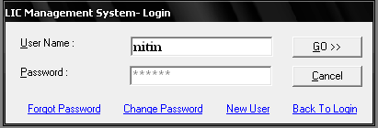

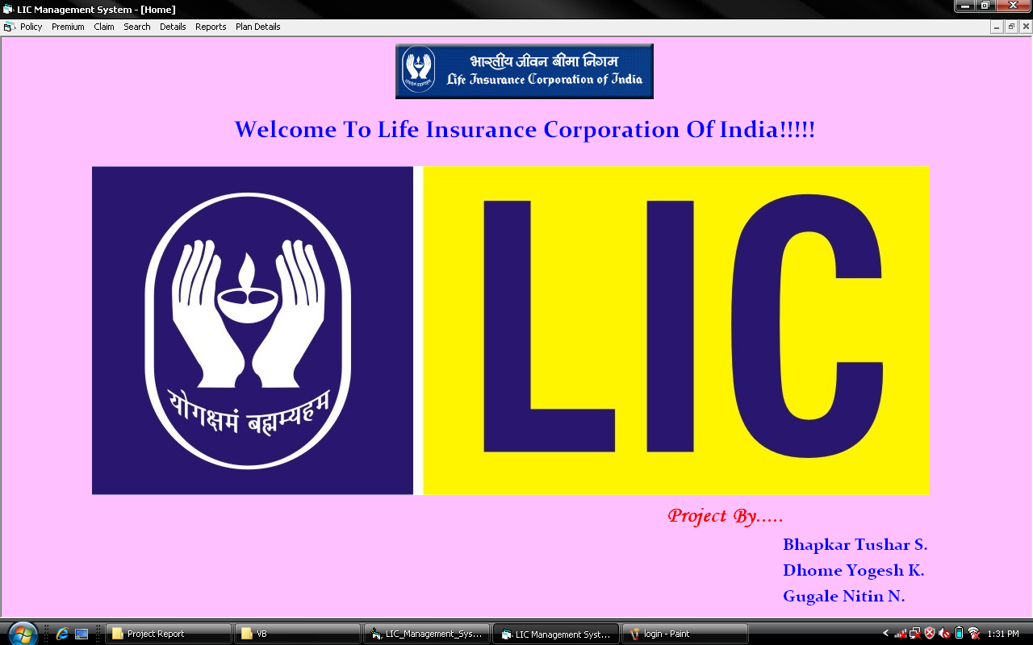

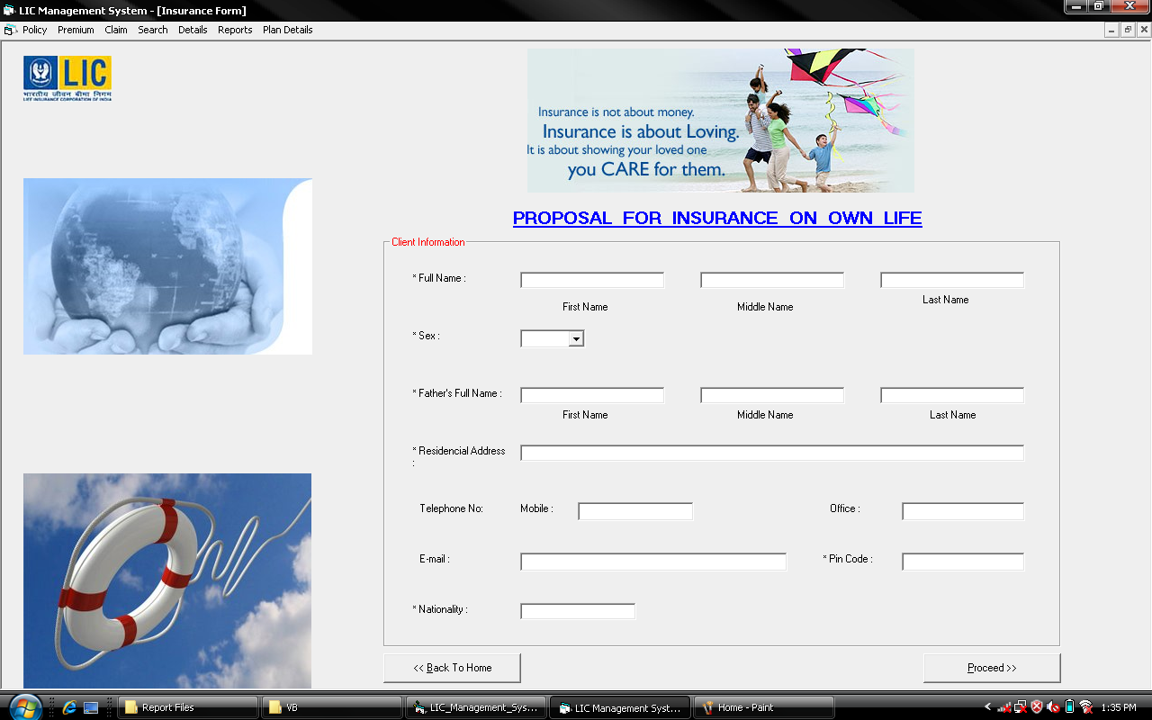

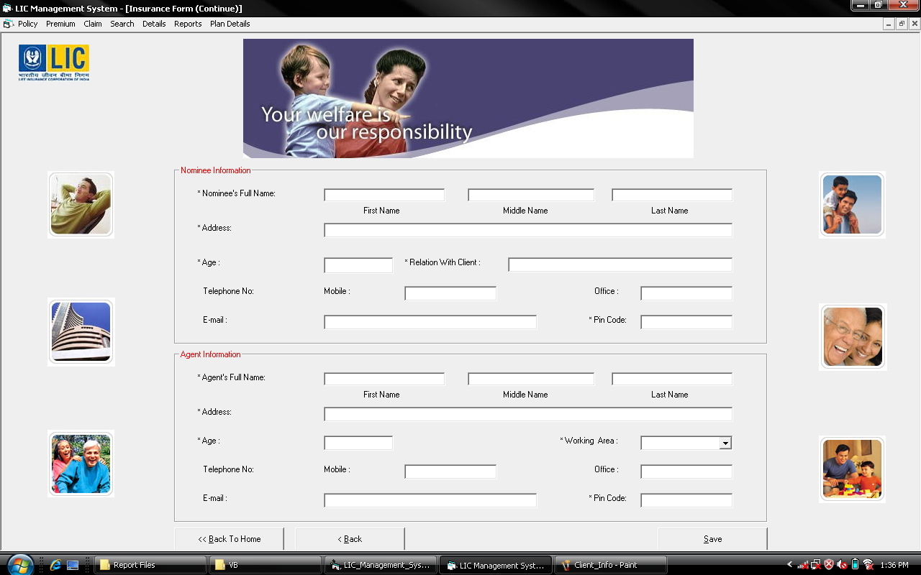

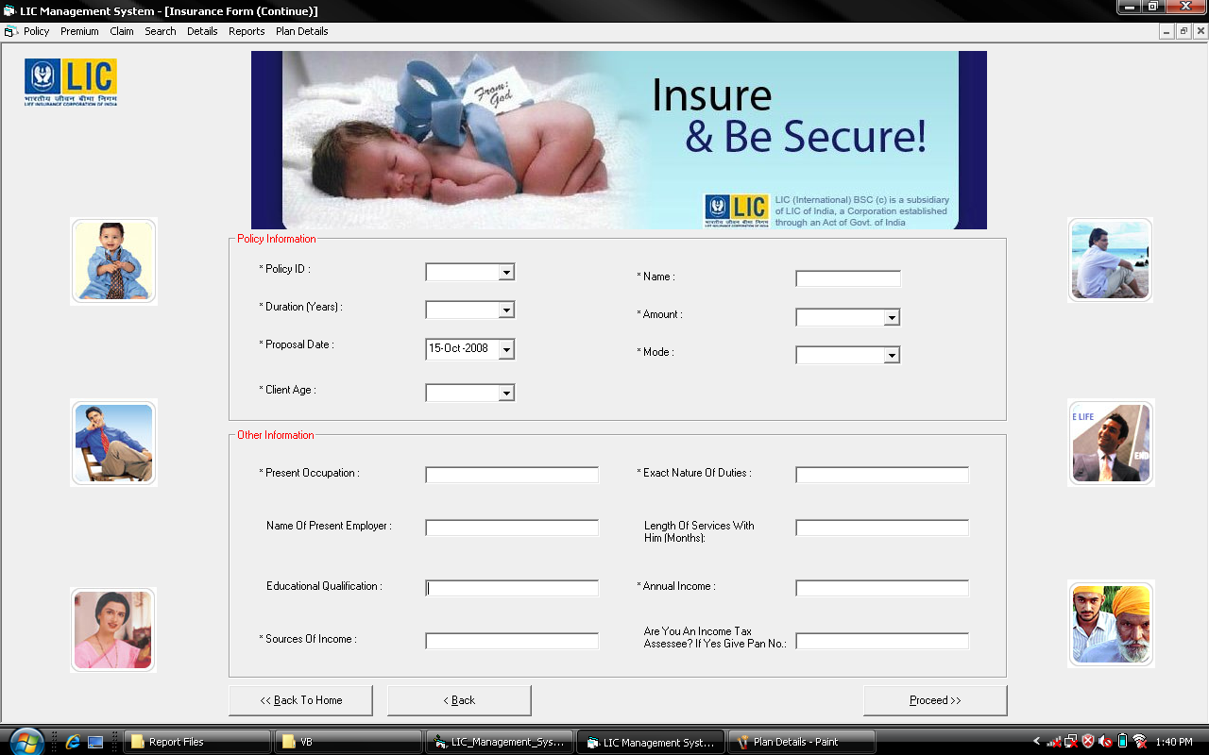

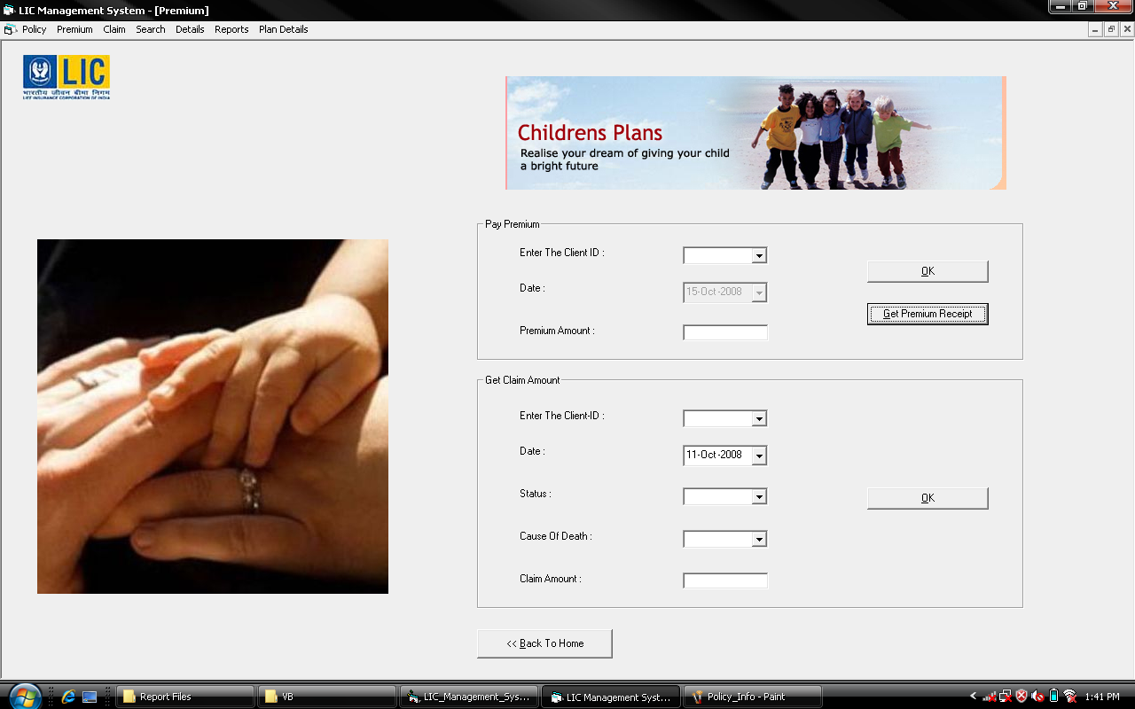

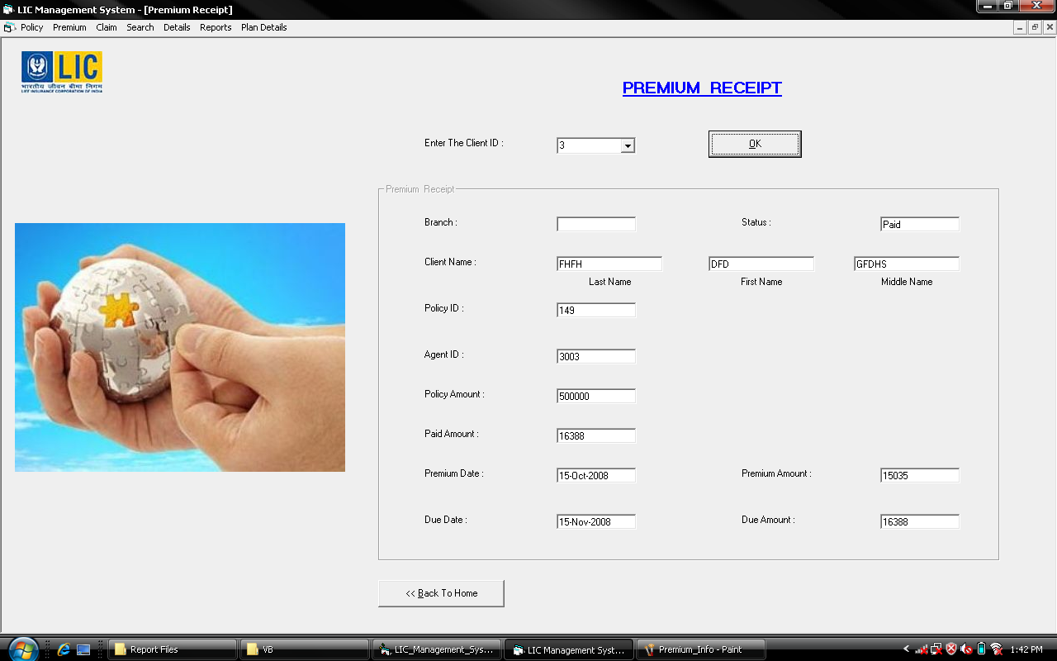

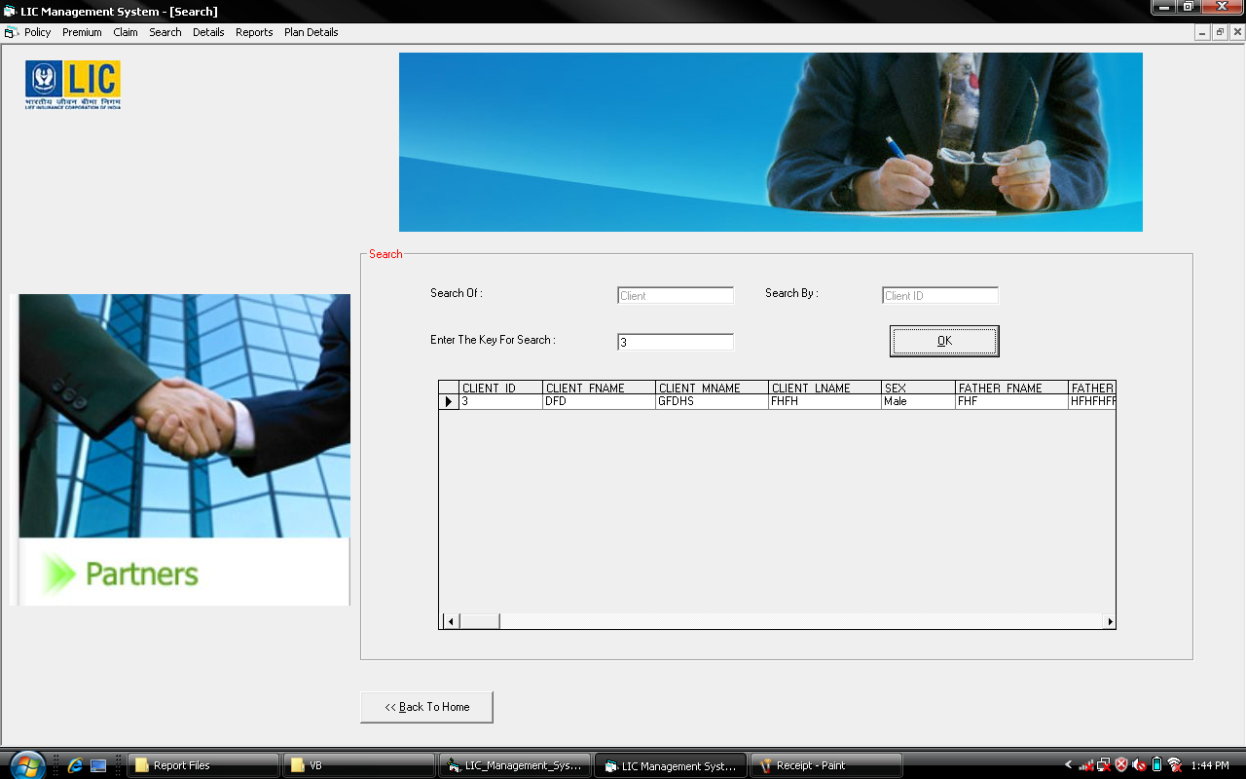

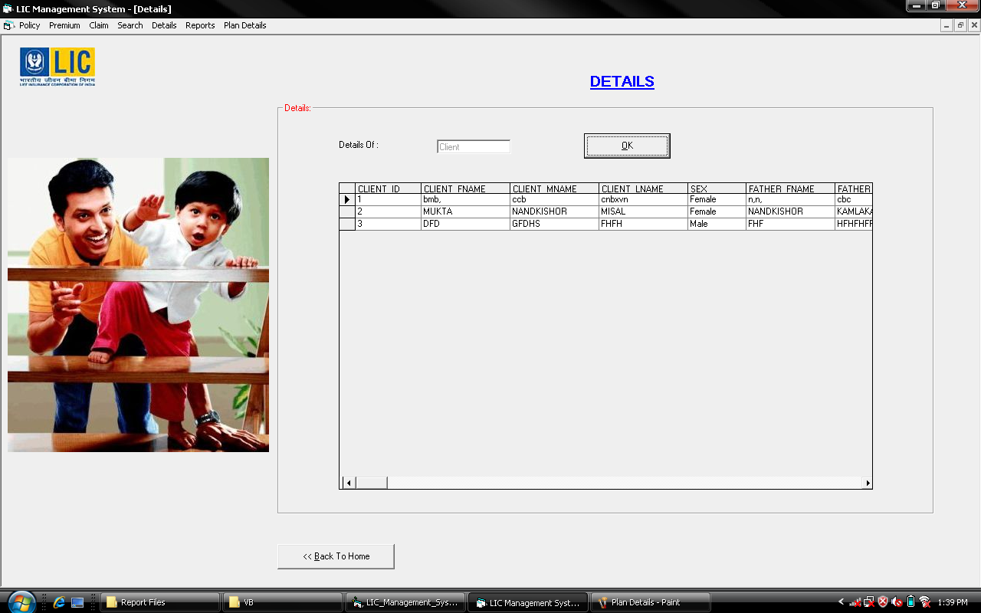

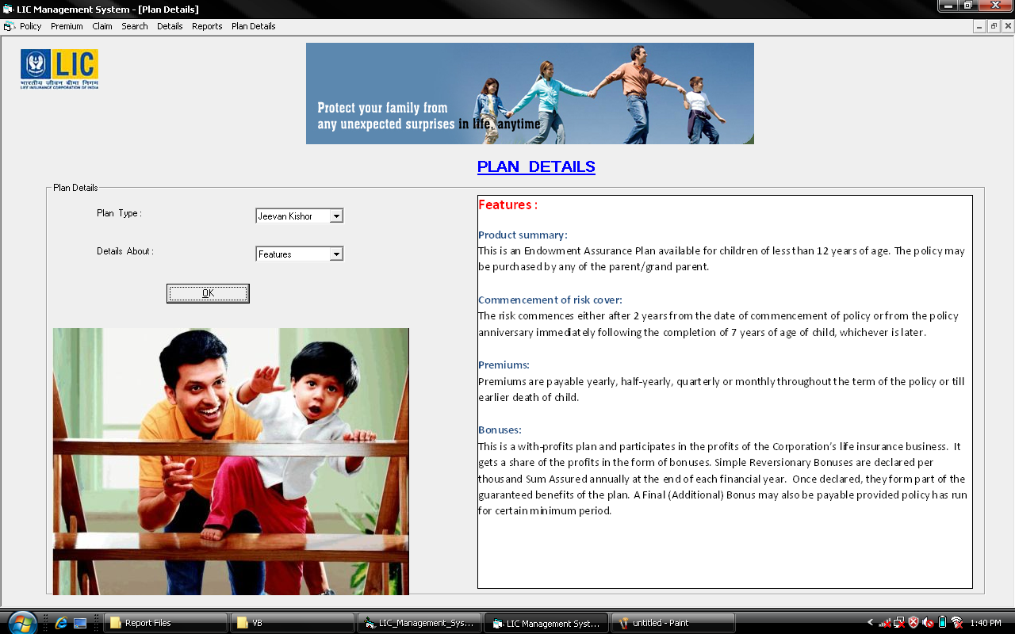

**7. BIBLIOGRAPHY**

Books used :

1. Black Book Of VB 6.0 - Steven Holzner

2. Database Management Systems - Koarth

3. SQL for professionals - Rajesh Naik

4. Database Management systems - Bipin Desai

Softwares used :

1. Microsoft Access
2. Microsoft Visual Basic 6.0

Language used :

SQL (Structured Query Language)